**CREATING THE EC2 INSTANCE WITH TERRAFORM SCRIPT**

**Step: 1: -**

*Create the Instance in AWS Console in EC2 Dashboard and open the instance with ssh tool*

**Step: 2:-**

*Inside the instance install the Terraform by using the below steps:*

**AMAZON LINUX:**

sudo yum install -y yum-utils shadow-utils

sudo yum-config-manager --add-repo https://rpm.releases.hashicorp.com/AmazonLinux/hashicorp.repo

sudo yum -y install terraform

**CentOS/RHEL:**

sudo yum install -y yum-utils

sudo yum-config-manager --add-repo https://rpm.releases.hashicorp.com/RHEL/hashicorp.repo

sudo yum -y install terraform

**UBUNTU/DEBIAN:**

wget -O- https://apt.releases.hashicorp.com/gpg | gpg --dearmor | sudo tee /usr/share/keyrings/hashicorp-archive-keyring.gpg

echo "deb [signed-by=/usr/share/keyrings/hashicorp-archive-keyring.gpg] https://apt.releases.hashicorp.com $(lsb_release -cs) main" | sudo tee /etc/apt/sources.list.d/hashicorp.list

sudo apt update && sudo apt install terraform

You can Install which instance you have based on that Install the Terraform.

*Check the version of Terraform is installed or not*

terraform -v

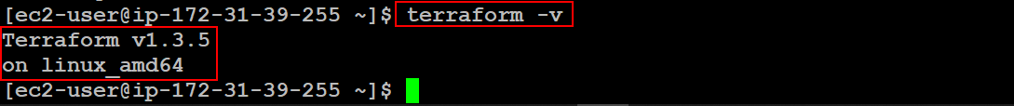

**Step: 3: -**

After Installation we need to create the AWS Security Credentials of **ACCESS_KEY** and **SECRET_KEY** compulsory.

For that we need to create the **IAM User** and giving the Permissions of **“AmazonEC2FullAccess”.**

After creating the IAM User you will get an **ACCESS_KEY** and **SECRET_KEY**.

For those **ACCESS_KEY** and **SECRET_KEY** to pass in the instance we need **aws-cli** is to be installed in the Instance.

**Step:4 : -**

*If the aws-cli is not installed, we need to install the aws-cli.*

*With below commands we can install the aws-cli:*

curl "https://awscli.amazonaws.com/awscli-exe-linux-x86_64.zip" -o "awscliv2.zip"

unzip awscliv2.zip

sudo ./aws/install

If below two commands are not working make sure install the unzip package with yum.

sudo yum install unzip -y

after try the below two commands.

*Now check the aws-cli version:*

aws --version



**Step: 5: -**

*After the installation of aws cli try to mention the ACCESS_KEY and SECRET_KEY by using this command:*

aws configure

*when we execute the command, we can see the below and we can give the security credentials there:*

[ec2-user@ip-172-31-39-255 ~]$ aws configure

AWS Access Key ID [None]: <your-access-key>

AWS Secret Access Key [None]: <your-secret-key>

Default region name [None]: ap-south-1

Default output format [None]:

**Step: 6: -**

*Create a Directory 🡺 Change the Directory 🡺 Inside the Directory Create a file with a format of “.tf” extension.*

mkdir demo

cd demo/

vi main.tf

*Inside the file of first.tf write the script of terraform of creating the EC2 Instance.*

terraform {

  required_providers {

    aws = {

      source  = "hashicorp/aws"

      version = "~> 4.0"

    }

  }

}

# Configure the AWS Provider

provider "aws" {

  region = "ap-south-1"

}

# Giving the EC2 Instance details for creating the Instance

resource "aws_instance" "AWSEC2Instance" {

    ami = "ami-069d9fecd19e7ed40"

    instance_type = "t2.micro"

    security_groups = ["default"]

    key_name = "two"

# Providing the name of creating Instance

    tags = {

        Name = "TF_Server"

    }

}

🡺 save the file.

**Step: 7: -**

Those commands we are running here we called as terraform life cycle

The commands are:

**terraform init**

**terraform plan**

**terraform apply**

*Run the Terraform script by using the commands as shown below:*

terraform init

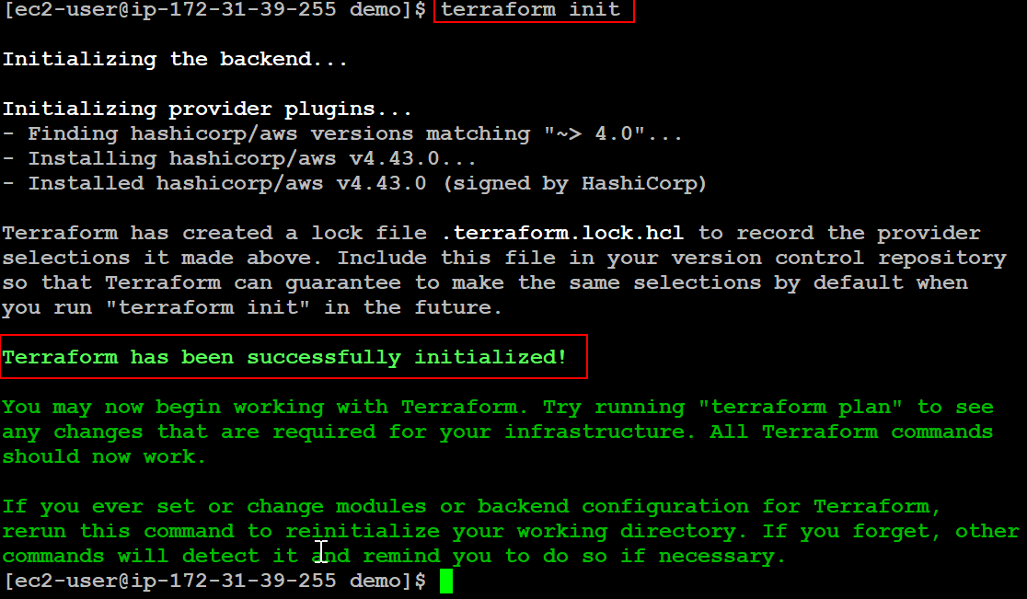

*After that we need to try another command:*

terraform plan

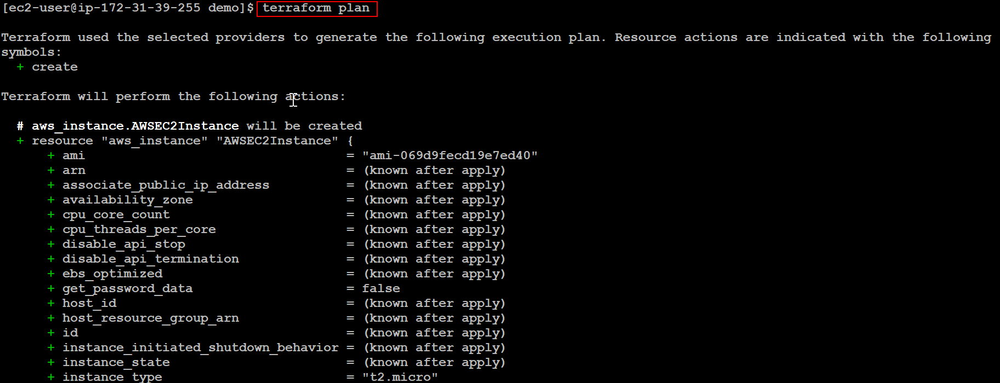

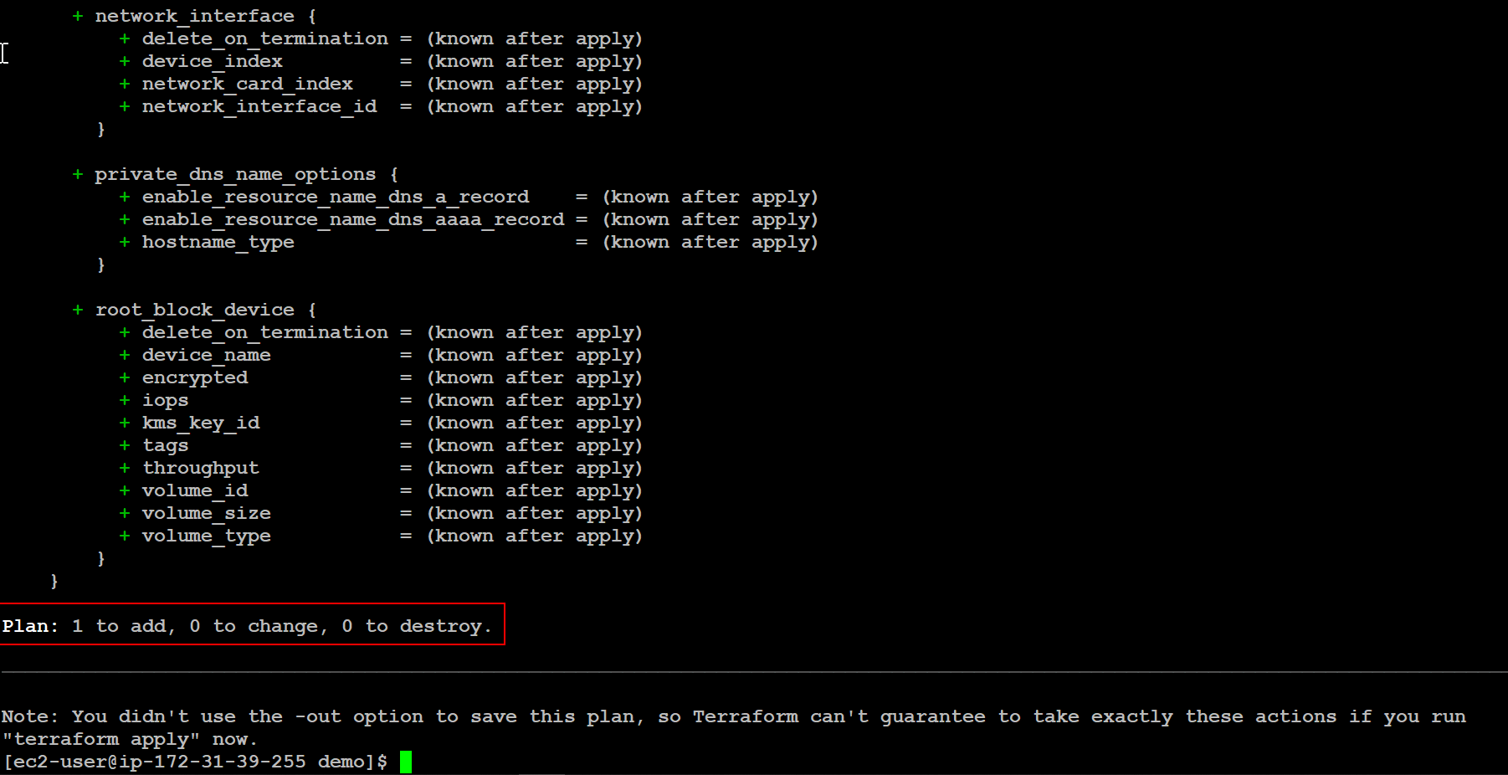

*Another command is*

terraform apply --auto-approve

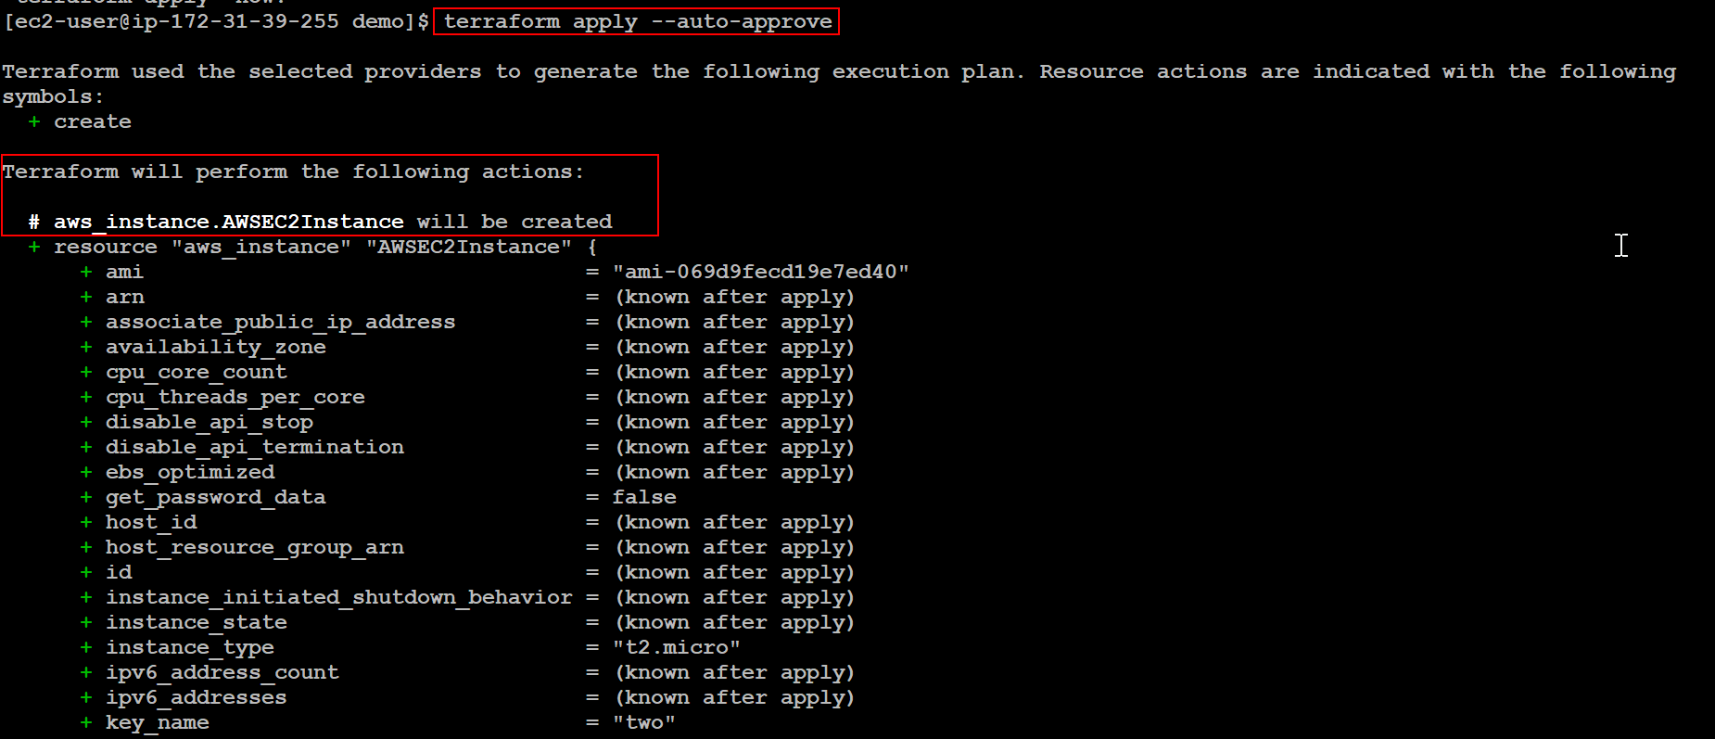

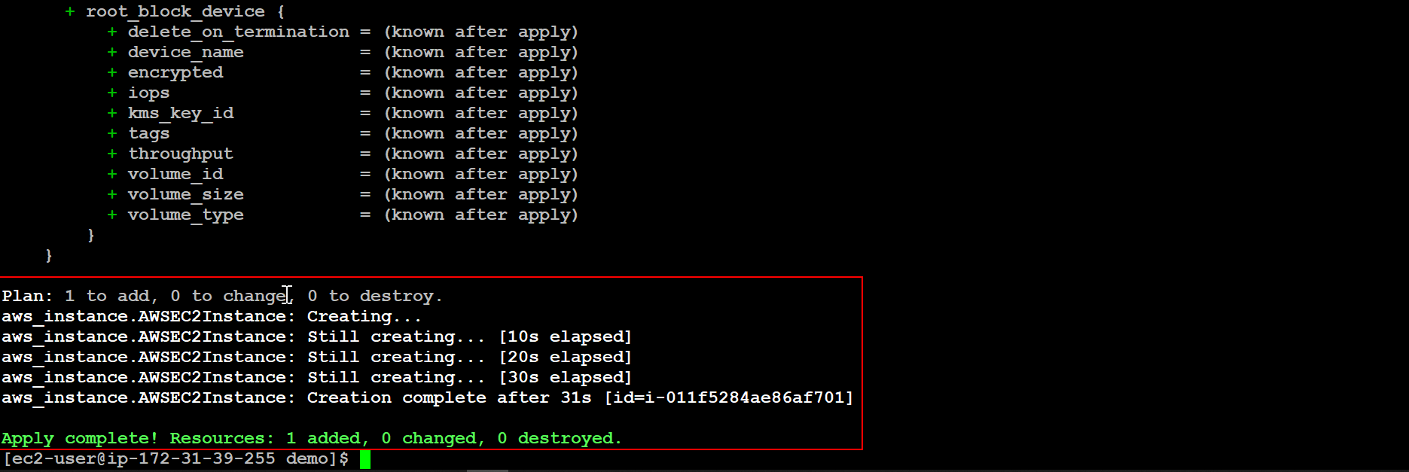

Here the terraform script run successfully.

**Step: 8: -**

*After we can see in the AWS Console in EC2 Dashboard we can see the created instance with the name of* ***TF_Server****.*

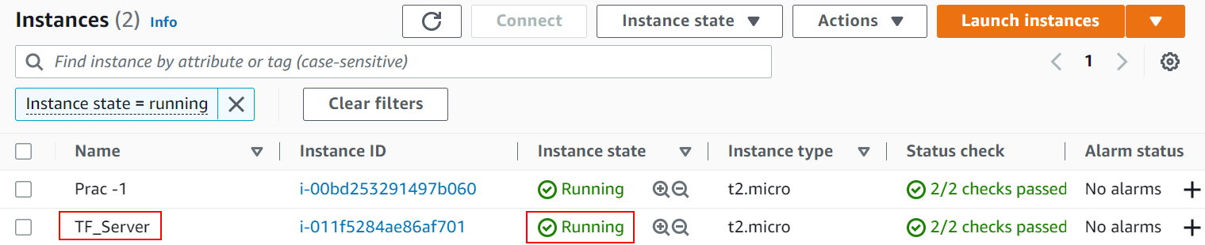

Here we can have the EC2 Instance by creating with Terraform Script.